**Gaming types**

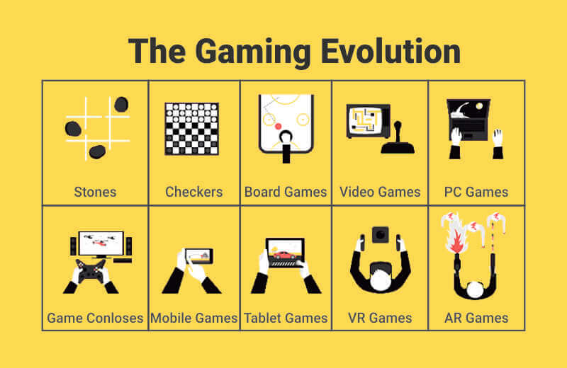

People these days are more addicted to gaming with various gaming technologies like PC, PS, Xbox, Switch, Smart-phones, etc. With the surge in the gaming industry and growing needs for the gamers, there are various sub mechanics available for a successful title release. Different types of gaming available are:

**VR and AR:**

AR or Augmented Reality is the reality with some add-ons to the existing screens like some animations or changes that one can experience with the original backgrounds. VR, on the other hand, is Virtual Reality that is a pseudo or artificial reality that provides an extraordinary experience of entering the gaming world with VR devices. Ivan Sutherland with his student Bob Sproull created the first AR/VR display in 1968 that was a head-mounted one, named ‘Swords of Damocles’. Pokemon Go, Ingress, Moss, InMind VR, etc, a wide range of gaming applications are available for AR and VR with their enhanced entertainment. Goldstein’s research surveys stated AR and VR accounting for about 5.2 billion USD in 2016, and according to Statista surveys, it is expected to reach 18.8 billion USD by the end of 2020. At present, around 88% of the mid-sized companies are trying to make use of AR/VR technologies for their applications.

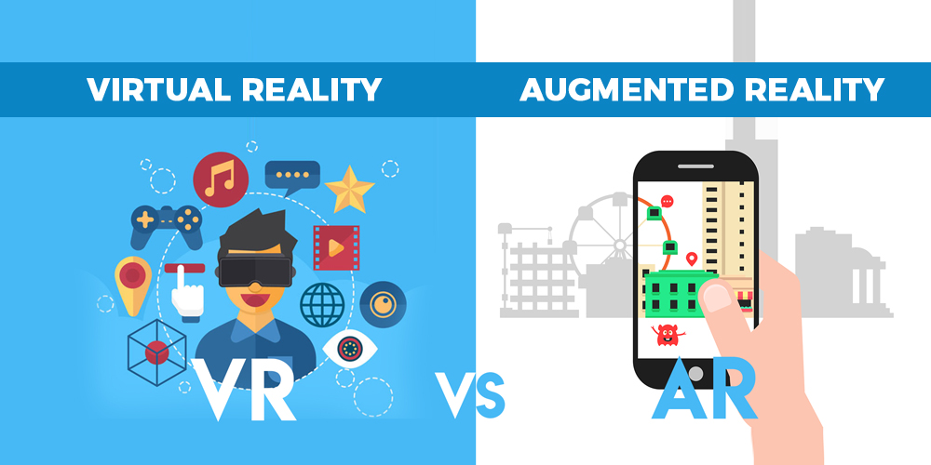

**Mobile Games:**

With any-where availability of mobile phones, they are the assets in gaming technology. Mobile games have provided recreation to people at any time like traveling, working, office-times, visiting anyone, and every other thing that one does. The whole of this giant journey started from Tetris in 1994 to Nokia’s Snake in 1997 and reaching the present-day destination of the blockbusters like Smash Hit, Candy Crush Saga, Angry Birds, etc. From the whole of the giant gaming industry, the mobile gaming market is about 50% of the shares. And, the leading mobile game publisher is ‘King’, and the top-grossing mobile game being ‘Roblox’.

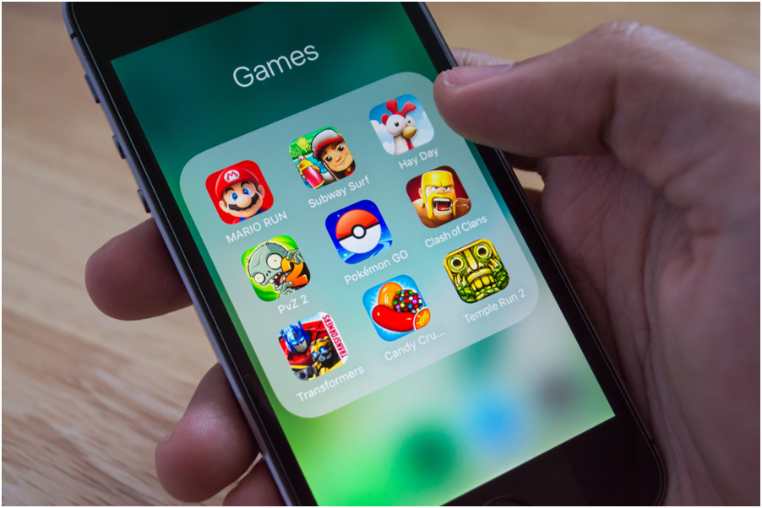

**AI-driven Games:**

Artificial Intelligence has a wide range of applications in various advancements. With AI flooding the market shares with its success pattern, it had marked its territory over the gaming industry too. AI enhances the responses and the adaptabilities with add-on automatic features in any application. During the Arcade games’ golden era, AI started with its success with various releases like Space Invaders in 1978, Galaxian in 1979, and Pac-Man in 1980. AI enhances the user experiences and thus about 15% of the companies only use it for better responses for the customers. AI is at the top in various technologies and in gaming, it excels with various releases like Halo Reach, StarCraft 2, and many more.

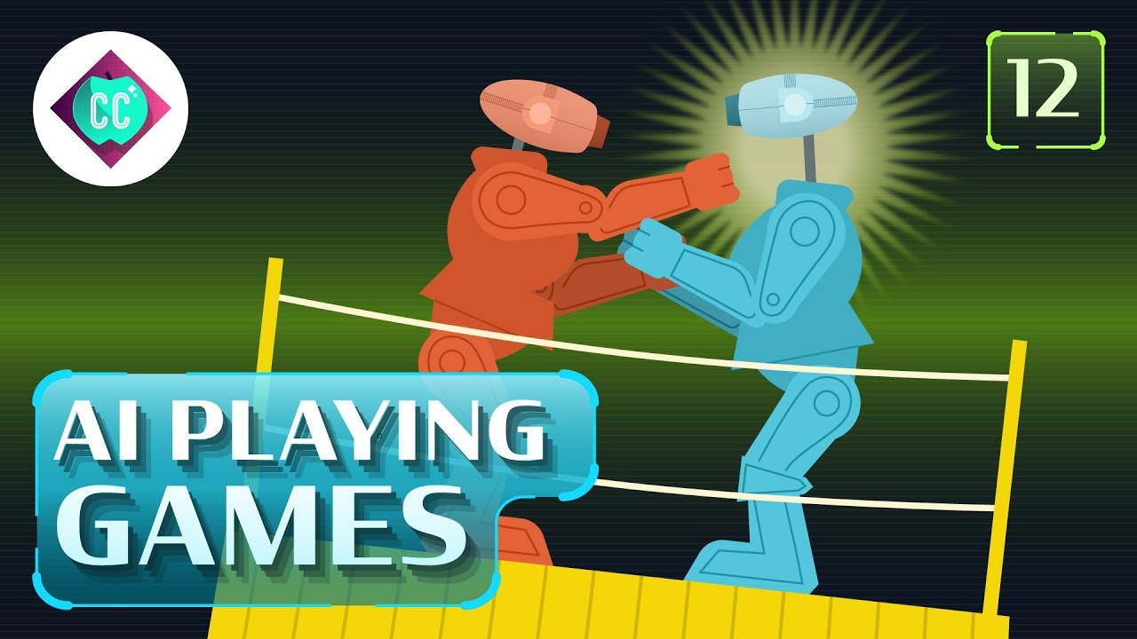

**Blockchain Games:**

Blockchain games rely on the concept of the chain of blocks representing cryptocurrency. Bit-coins and eventually gambling games are the most prominent development of blockchain technology. Betting attracts millions of folks to Vegas, and this advancement in the gaming industry enhances a wide user-base for the released technology. Various casinos and betting games and the other games supporting bitcoin that are dominating the gaming industry are Crypto Kitties, My Crypto Heroes, The Six Dragons, etc. With further blockchain game releases, the blockchain market is expected to rise to 39 billion USD by 2025.

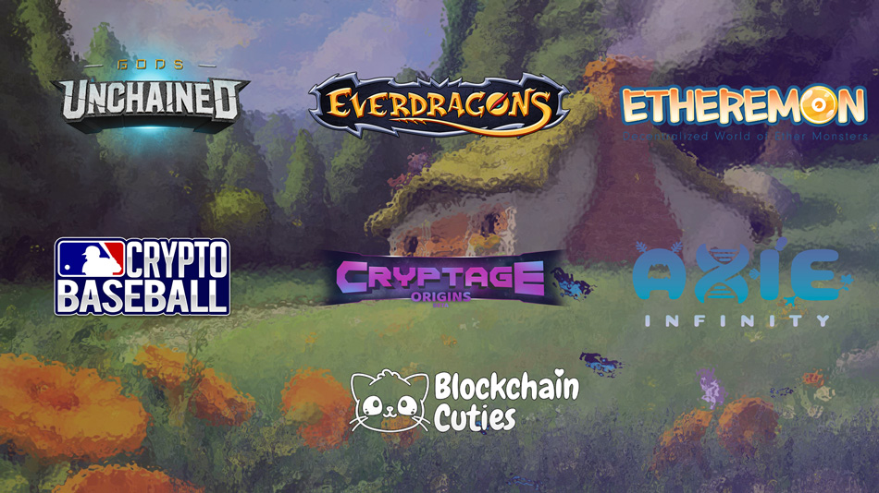

**Internet Games:**

Strategy games, first-person shooters, hyper-casual game varieties, multiplayer games, all of them are the sub-genres available for online gaming. Online gaming is the most flooded sector with most grossing gaming applications and with this, in 2019, the online gaming industry estimated a revenue generation of about $16.9 billion. MUDs are the ancient first forefathers in the online gaming industry released in the 1970s. After that, many blockbuster titles came into the view like Islands of Kesmai in 1984 and several releases in the 1990s. The online gaming is the most addictive with several popular titles of the present decade like PUBG, Mini Militia, Ludo King, Over Cooked 2, etc.

